Packt Chapter Styles | All Examples
#1 This is how P – Regular style will look:
Whether you have done an analysis in real time while capturing traffic, or you have analyzed a pre-captured file, you're generally faced with a huge amount of data. How do you make sense of all this data? Most likely, you will benefit from filtering the traffic to narrow the scope. To achieve this, we use filters, so that Wireshark only displays the traffic that you want to see.
___________________________________________________________________________
#2 This is how P – Bold style will look:
This chapter reviews the many ways Wireshark can filter traffic.
___________________________________________________________________________
#3 This is how P – Italics style will look:
To help your learning of the different ways to refine your view.
___________________________________________________________________________
#4 This is how P – Keyword style will look:
We'll cover when to filter Traffic and outline the difference between display and capture filters.
___________________________________________________________________________
#5 This is how P – Code style will look:
So that you can refine your java.exe file when filtering traffic.
___________________________________________________________________________
#6 This is how P – URL style will look:
We'll review ways to create more complex filters (https://www.google.com) by using the expression builder.
___________________________________________________________________________
#7 This is how P – Source style will look:
apt-get install node.js
apt-get uninstall node.js
___________________________________________________________________________
#8 This is how P – Callout style will look:
We'll then go through capture filters and how they use syntax that is different than display filters. Finally, because filters are so handy, we'll cover some tricks, shortcuts, and common filters that will help you achieve a more effective analysis.
___________________________________________________________________________
#9 This is how P – Callout Heading style will look:
Note
While in the course of your daily routine, the network starts to experience a significant slowdown. You check your Intrusion Detection System (IDS) and anti-malware protection, and there is no evidence of intrusion. At that point, you grab a quick capture to determine the source of the slowdown. Wireshark, along with many other packet analysis tools, has the ability to take a large capture, filter on specific traffic, and refine your view to help with analysis.
___________________________________________________________________________
#10 This is how L – Bullets style will look:
- Filtering network traffic
- Comprehending display filters
___________________________________________________________________________
#11 This is how L – Numbers style will look:
- Creating capture filters
- Understanding the expression builder
___________________________________________________________________________
#12 This is how L – Regular style will look:
- Discovering shortcuts and handy filters
Filtering network traffic
________________________________________________________________________
#13 This is how L – Source style will look:
- Wireshark has several options to filter traffic:
Display filters: Used during an active capture or on a pre-captured packet
___________________________________________________________________________
#14 This is how SC – Source style will look:
Capture filters: Applied prior to capture to only display a certain type of traffic
Expressions: Creates complex filters using logical operators
___________________________________________________________________________
#15 This is how SC – Highlight style will look:
When filtering traffic, there is a difference between display filters and capture filters. In the next section, let's explore the difference.
___________________________________________________________________________
#16 This is how SC – Heading style (Filename above code snippet) will look:
Cjava.py
When working with packet captures, it appears as if the capture and display filters are the same. However, although the two work in similar ways, capture and display filters each use their own syntax.
___________________________________________________________________________
#17 This is how SC – Link style (GitHub Link below the code snippet) will look:
While using Wireshark, there are four main phases of packet analysis as discussed in Chapter 2, Using Wireshark NG, which are Gather, Decode, Analyze, and Display, as shown in the following diagram:
https://github.com
________________________________________________________________________
#18 This is how IMG – Caption style (Figure and Figure caption) will look:
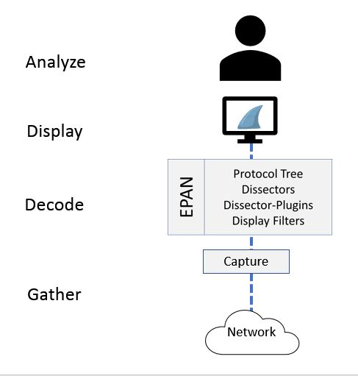
Phases of packet analysis
___________________________________________________________________________
#19 This is how H1 – Section style (Heading 1) will look:

Gathering network traffic
___________________________________________________________________________
#20 This is how H2 – Heading style (Heading 2) will look:

The packets pass through the appropriate capture engine
___________________________________________________________________________
#21 This is how H3 – Subheading style (Heading 3) will look:

NPcap or WinPcap
___________________________________________________________________________
#22 This is how H4 – Subheading style (Heading 4) will look:

Capture filters
___________________________________________________________________________
#23 This is how P - Quote style will look:
“use the Berkley packet filter syntax, and when used, Wireshark drops any packets that are not in the filter. You can read more about this in The BSD Packet Filter: A New Architecture for User-level Packet Capture”
___________________________________________________________________________
#24 This is how SP – Editorial style (Heading 1) will look:
Please do not delete this paragraph.
________________________________________________________________________
#25 This is how L2 – Bullets style will look:
- Filtering network traffic
- Comprehending display filters
________________________________________________________________________
#26 This is how L3 – Bullets style will look:
- Filtering network traffic
- Comprehending display filters
- Glow
________________________________________________________________________
#27 This is how L2 – Numbers style will look:
- Filtering network traffic
- Comprehending display filters
________________________________________________________________________
#28 This is how L2 – Alphabets style will look:
- Filtering network traffic
- Comprehending display filters
________________________________________________________________________
#29 This is how L3 – Numbers style will look:
- Filtering network traffic
- Comprehending display filters
- Glow
- Dark

